How to use the Tenant File DirectPAY service

Thank you for ordering the Tenant File DirectPAY service. This User’s Guide will help you get started quickly so that you can easily post the rent payments into the Tenant File Property Management Software.

Here is the main screen. All DirectPAY actions take place from this screen:
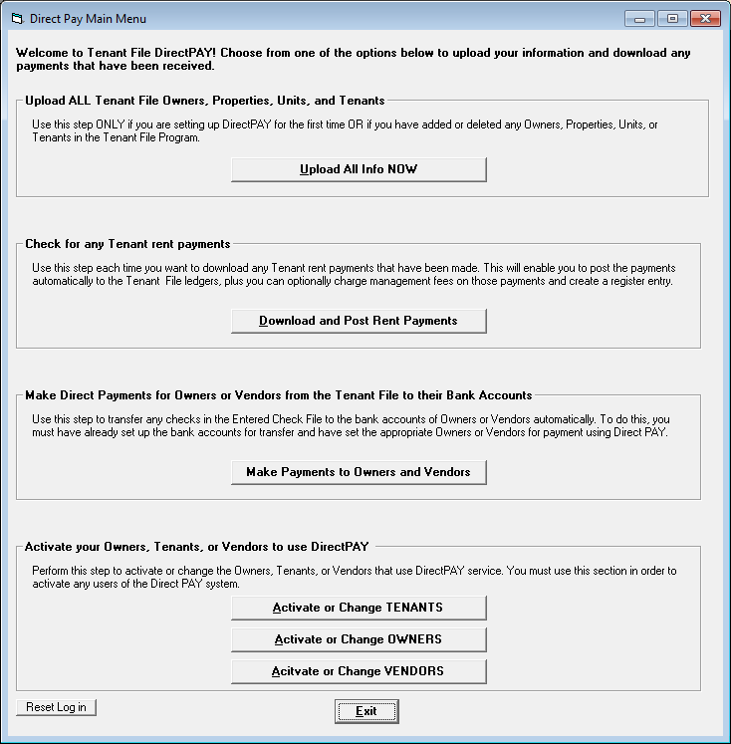

How do I get started?
Step 1:
Click on the ‘Reset Log in’ button to enter your User name, Password, and URL. These will be given to you by Revo Payments.
Here is the screen you will see:
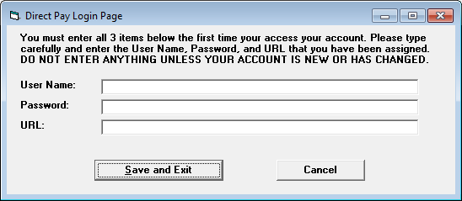

It is very important that you type everything exactly or you won’t be able to log in. Once this is set, you will not need to log in again unless your User Name or Password change.

Step 2:
Click the button ‘Upload All Info NOW’. This will upload the basic Tenant File linking information to Revo so that your account can be automatically created. No private information or transactions are transferred.

Step 3:
Select the Tenants that will be paying through the DirectPAY system by clicking the ‘Activate or Change Tenants button: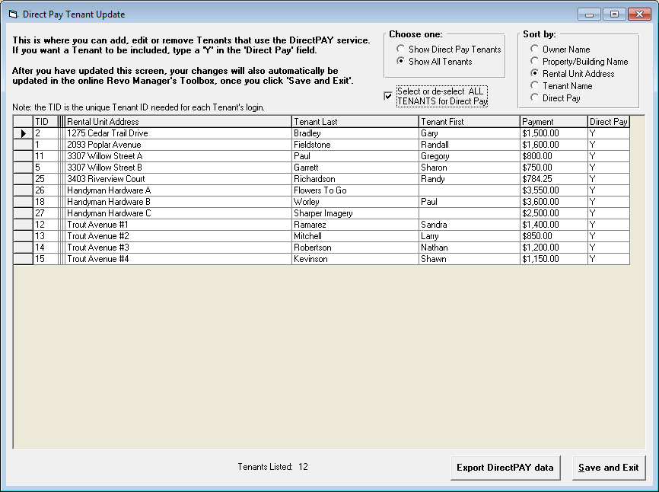
The ‘TID’ is the unique ‘Tenant ID’ code that your tenants will use to access their account. The only column that you can change is the ‘Direct Pay’ column on the far right side. This is where you will enter ‘Y’ for any tenants that are set up for DirectPAY and an ‘N’ for any that are not (or leave blank).

Once you have updated this screen, click ‘Save and Exit’, then the Tenant File will upload this information to the Revo Payment system so that your tenants may set up their accounts.

Step 4:
Once your tenants have paid their rent online, you can pull those transactions into the Tenant File ledgers. Click the ‘Download and Post Rent Payments’ button to see if there are any payments available to be posted. If there are payments, they will be pulled into the screen below:

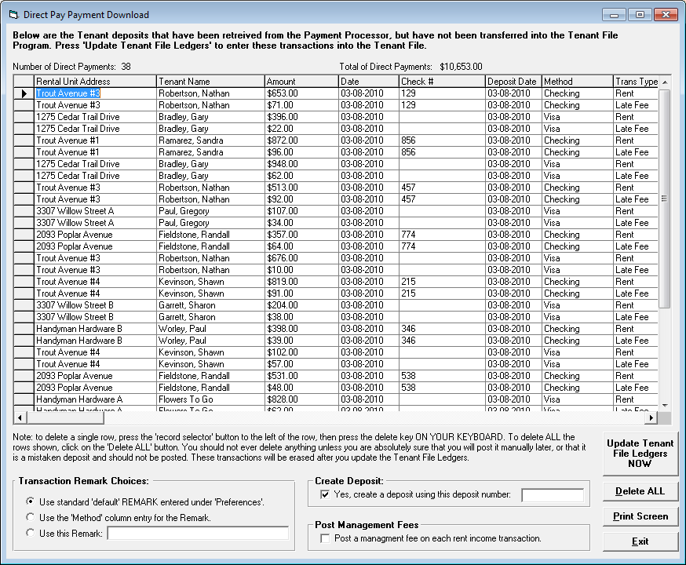

You have several important choices when posting the transactions into the Tenant File ledgers:

Transaction Remark Choices:
This determines the ‘Remark’ for each transaction that is posted to the ledger. You can use the ‘default’ remark you entered under ‘Preferences > Edit Account Defaults’, you can use the entry in the ‘Method’ column (ex. Checking, Vista, etc), or you can enter your own remark.

Create Deposit (selected by default):
This will create a bank deposit for the transactions posted to your ledger when checked.

Post Management Fees (NOT selected by default):
If you want the Tenant File to post a management fee based on your settings in the Tenant File, put a check mark in this box.

Update Tenant File Ledgers NOW:
This is final. It will post all the transactions to your ledgers and permanently delete the entries so that the next batch of payments can be downloaded.

Delete ALL:
Do not ever use this option unless you are sure all of the show transactions are in error. This is a permanent delete.

You can have the Tenant File check for outstanding payments each time you enter the program:
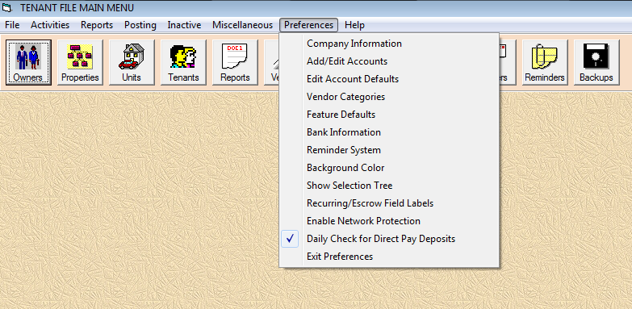

Just put a check mark next to Daily Check for Direct Pay Deposits and you will be notified when payments are available to be posted.

If you have any questions with the Tenant File integration steps above, contact web support by going to Help > Web Support within the Tenant File program.

Making Owner and Vendor Payments

DirectPAY has the capability to deposit Owner or Vendor payments Vendors directly to their bank accounts. This unique capability will save you the time, money and the effort that is needed to create and send checks manually.

How it works
Within the Tenant File software, there are numerous ways to create checks, both manually and automatically. All of those checks are initially displayed in your ‘Entered Check File’, which you can view by clicking on the Checks/Deposits button. Before you print the checks, you will instead go to Posting > Direct Pay to see which payments can be made directly. Select the checks you want to pay using DirectPAY, and those checks will be automatically uploaded to the Revo Property Pay system, deposited to the correct Owner or Vendor bank account, transferred from the ‘Entered Check’ file to the ‘Printed Check’ file within the Tenant File, and posted to your ledgers. All automatically posted and done in seconds!

Of course, for any Owner or Vendor that you want to pay this way, you will need to get set up with Revo Payment Services ahead of time, so that the bank routing numbers and account numbers can be created within the system.

Once you are set up with Revo, you will need to indicate within the Tenant File those Owners and Vendors that are eligible for DirectPAY. From the main DirectPAY screen you will click on the appropriate button to activate your Owners or Vendors.

To set up your Owners, click on the button ‘Activate or Change Owners’:

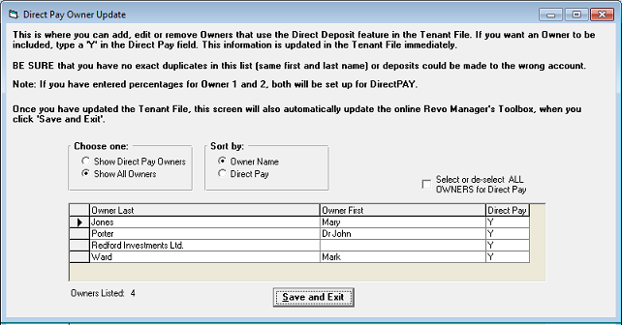

The instructions are on screen for you. Simply put a ‘Y’ next to the Owner that your have set up through the Revo Property Pay system. Then that Owner is ready to use the DirectPAY system.

To set up your Vendors, click on the button ‘Activate or Change Vendors’:

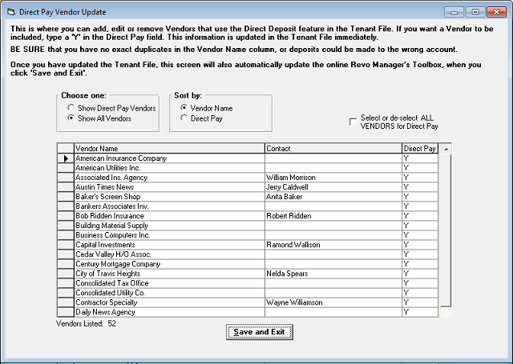

The instructions are on screen for you. Simply put a ‘Y’ next to the Vendor that your have set up through the Revo Property Pay system. Then that Vendor is ready to use the DirectPAY system.

Now you are ready to make any payments for Owners or Vendors that are set up for DirectPAY. From the main DirectPAY menu, click on the button ‘Make Payments to Owners and Vendors’:

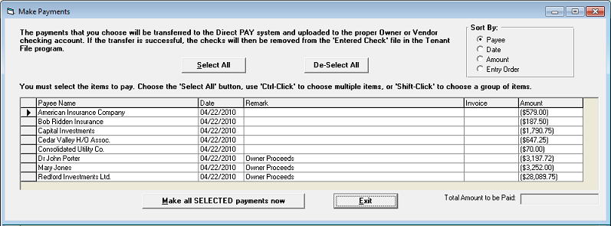

Choose which payment you want to make by clicking on the button on the left to highlight the row. You can use Shift-Click to highlight multiple rows. When ready click ‘Make all SELECTED payments now’.

